**Melissa Moreno**

**Colleen Davoli**

**SELECTION GRADIENTS IN GOLDENROD**

**Introduction**

Examining how natural selection acts on populations today is an important link between the studies of evolution and ecology. As natural selection can lead to evolution in populations, examining how selection acts today may provide an understanding of how current characteristics in a population have been shaped by evolution.

We can see the effects of selection by comparing the distribution of phenotypes before and after selection acts (i.e. before and after the individuals die). To do this, we can compare the means and variances of the distributions and look for three types of effects: 1) directional selection, 2) stabilizing selection, 3) disruptive selection. Think about how the means and variances of the population will respond to each of these types of selection.

***Our goal is to examine how the various forces of selection act on goldenrod gall flies. We will do this by looking at the phenotypic distribution of gall sizes and determining how the distributions change after selection by different sources of mortality.***

**Natural History of the *Solidago-Eurosta* System**

The goldenrod fly is called *Eurosta solidaginis* and its host plant is the tall goldenrod *Solidago altissima*. Female flies lay an egg in terminal buds of goldenrods in the spring. The larvae (1st stage of developing insect) burrow through the bud into the meristematic tissue of the plant. Here the fly begins feeding on the plant tissue creating a chamber and inducing the formation of a gall. The galls are growth of the plant caused by high rates of cell division (like a tumor) induced by the insect. The gall reaches its maximum size about six weeks after the females lay the eggs and the larvae reach full size by September. By mid September the third-instar larvae excavate an exit tunnel that does not penetrate the gall’s exterior 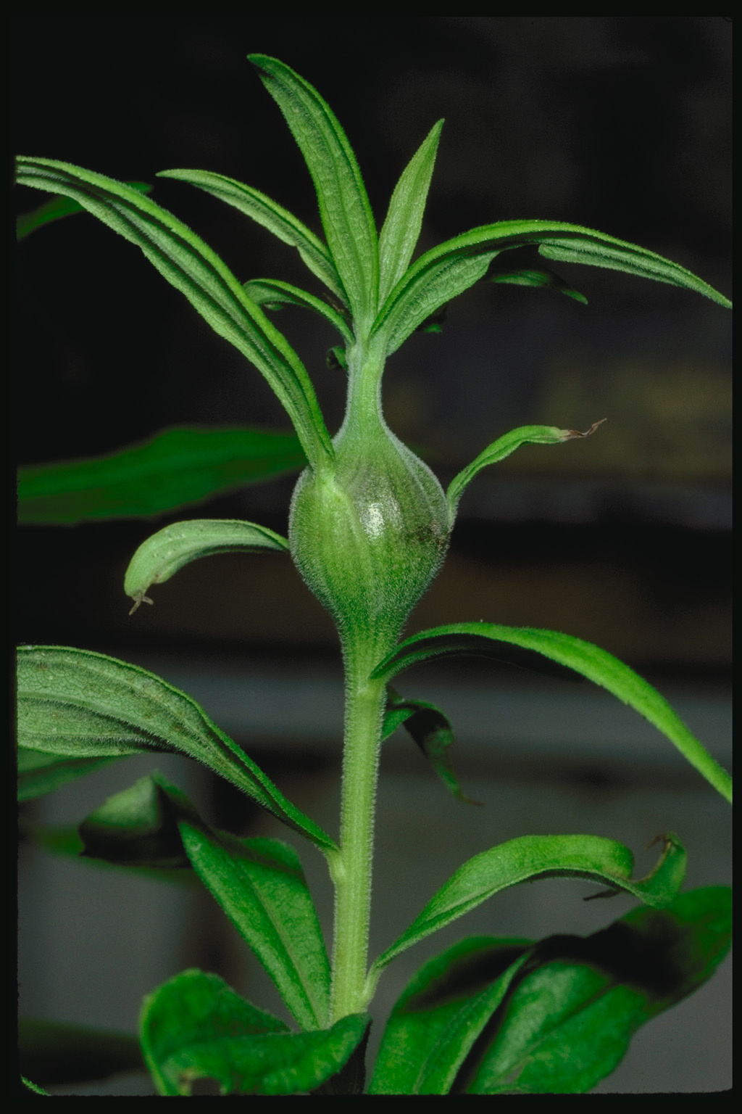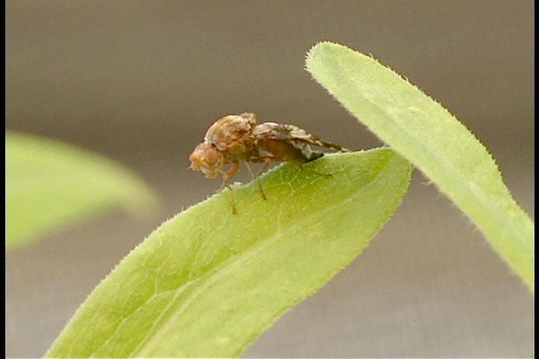(the orientation of the exit tunnel is variable). After excavating the exit tunnel the larvae return to the central chamber where they will remain until spring.

Abrahamson and Weis have studied how the characteristics of the gall are under the influence of the insect AND the plant. Because of this, the gall can evolve from selection on the plant OR the gall fly**.** Previous work shows that the gall diameter is heritable for the insect AND the plant.

**Left:** gall in goldenrod plant *Solidago altissima.* **Above:** Female goldenrod fly, *Eurosta solidagin.* For more info see: www.facstaff.bucknell.edu/abrahmsn/solidago/main.html.

**Sources of *Eurosta* Mortality**

1. **Parasitoid wasps** – Parasitoids are insects that lay their eggs in or on a host and develop by killing and eating the entire host. The wasp *Eurytoma gigantea* is a parasitoid of the gall fly. A female inserts eggs into the center of the gall (by piercing the gall with her ovipositor). The wasp larva eats the fly larva and then takes over the gall as its home. Flies in smaller galls may be more susceptible to being attacked by this wasp because wasps are limited in the size of galls they attack by their ovipositor length. Due to this, wasps may be a factor causing directional selection in the size of galls.
2. **Bird predators** – During the winter, downy woodpeckers (*Picoides pubescens*) and black-capped chickadees (*Parus atricapillus*) eat the fly larvae by pecking through the gall. The birds detect galls visually, so larger galls may be seen more easily and the flies within may suffer greater mortality. Therefore, birds may also cause directional selection on the gall sizes.
3. **Other herbivores** – Lots of herbivorous insects eat goldenrods. One common such insect is *Mordellistena unicolor*, a beetle that lays its eggs on the gall’s surface. The larvae burrow into the gall and may eat the larva.

NOTE: These data were collected for both green and brown galls. Green galls are on goldenrod plants that had been produced during that year (they’re still alive, hence: green), and had been subject to wasp parasitism but not bird predation. Brown galls are those that had been produced the previous year (the goldenrod plant has died, hence: brown). They have therefore been subject to selection from both wasp parasitism and bird predation over the winter.

**Data Analysis** – Everyone in the class will analyze the same dataset, which will be posted on Canvas. While you are free to discuss this lab with your classmates, *each of you should produce* ***your own*** *results and figures.*

For this lab, we’re going to analyze the fate data for each year’s galls separately. In other words, do all steps for each data set, “green” (this year’s, pre-bird selection) or “brown” (last year’s, post-bird selection) galls.

To do this, highlight all columns, choose **Sort** from the **Data** menu, sort the cells by the “Fate” column.

Highlight the gall sizes and heights for flies that are alive (not parasitized or dead), copy and paste them into a new columns called “Survivor Height” and “Survivor Size”. Copy and paste the values for flies that died into new columns called “Dead Height” and “Dead Size”.

1. Calculate the rates of mortality (% killed), and the rate of fly survival (% survived)

|  |  |  |
| --- | --- | --- |
|  | Mortality rate | Survival rate |
| Green galls | 83.6% | 16.3% |
| Brown galls | 78% | 22% |

1. Calculate sample sizes, averages, variances, standard deviations, and standard errors for each column (before selection, survivors, dead). In a cell at the bottom of each column type “=count(”, then highlight the column of data and hit return. Type “=average(“ to get the average, in the cell below that. Type “=var(“ to get the variance, and “=stdev(“ to get the standard deviation. Remember, standard error is the st. dev. divided by the square root “=sqrt(“ of the sample size.

|  |  |  |  |  |  |  |
| --- | --- | --- | --- | --- | --- | --- |
|  | GREEN GALLS | | | | | |
|  | Gall Diameter | | | Gall Height | | |
|  | Before selection | Survivors | Dead | Before selection | Survivors | Dead |
| Sample Size (n) | 190 | 32 | 158 | 190 | 32 | 158 |
| Average | 18.30 | 19.43 | 17.09 | 76.50 | 64.07 | 78.78 |
| Variance | 9.86 | 4.83 | 10.65 | 216.58 | 92.35 | 208 |
| St. Dev. | 3.14 | 2.20 | 3.26 | 14.72 | 9.61 | 14.42 |
| St. Error | 0.23 | 0.39 | 0.26 | 1.07 | 1.7 | 1.15 |
|  | BROWN GALLS | | | | | |
| Sample Size (n) | 82 | 19 | 63 | 82 | 19 | 63 |
| Average | 18.34 | 18.83 | 18.20 | 73.73 | 73.61 | 73.78 |
| Variance | 12.21 | 6.01 | 14.12 | 194.13 | 200.49 | 199.85 |
| St. Dev. | 3.49 | 2.45 | 3.75 | 13.93 | 14.15 | 14.14 |
| St. Error | 0.38 | 0.56 | 0.47 | 1.54 | 3.24 | 1.78 |

1. Determine whether the mean of the survivors is significantly different from the mean of the pre-selection galls, using a t-test (follow the instructions from the t-test handout for conducting t-tests in Excel). However, because our samples (before/after selection) are independent, we will be using a regular t-test, not a paired t-test.

GALL DIAMETER:

Green galls: t-statistic:_- 1.96

|  |  |  |
| --- | --- | --- |
| t-Test: Two-Sample Assuming Equal Variances | | |
|  |  |  |
|  | *Variable 1* | *Variable 2* |
| Mean | 18.29879 | 19.43375 |
| Variance | 9.86841 | 4.818256 |
| Observations | 190 | 32 |
| Pooled Variance | 9.156797 |  |
| Hypothesized Mean Difference | 0 |  |
| df | 220 |  |
| t Stat | -1.96284 |  |
| P(T<=t) one-tail | 0.025463 |  |
| t Critical one-tail | 1.651809 |  |
| P(T<=t) two-tail | 0.050925 |  |
| t Critical two-tail | 1.970806 |  |

p-value: one-tail is 0.02 and two-tail is 0.05

Significantly Different? **Y**/N

Brown galls: t-statistic: -0.5

|  |  |  |
| --- | --- | --- |
| t-Test: Two-Sample Assuming Equal Variances | | |
|  |  |  |
|  | *Variable 1* | *Variable 2* |
| Mean | 18.34695 | 18.83684 |
| Variance | 12.21731 | 6.010234 |
| Observations | 82 | 19 |
| Pooled Variance | 11.08875 |  |
| Hypothesized Mean Difference | 0 |  |
| df | 99 |  |
| t Stat | -0.5778 |  |
| P(T<=t) one-tail | 0.282354 |  |
| t Critical one-tail | 1.660391 |  |
| P(T<=t) two-tail | 0.564708 |  |
| t Critical two-tail | 1.984217 |  |

p-value: one tail 0.28 and two-tail 0.56

Significantly Different? Y/**N**

GALL HEIGHT:

Green galls: t-statistic: 2.51

|  |  |  |
| --- | --- | --- |
| t-Test: Two-Sample Assuming Equal Variances | | |
|  |  |  |
|  | *Variable 1* | *Variable 2* |
| Mean | 76.49556 | 64.07143 |
| Variance | 216.5827 | 92.34905 |
| Observations | 45 | 7 |
| Pooled Variance | 201.6747 |  |
| Hypothesized Mean Difference | 0 |  |
| df | 50 |  |
| t Stat | 2.153247 |  |
| P(T<=t) one-tail | 0.018074 |  |
| t Critical one-tail | 1.675905 |  |
| P(T<=t) two-tail | 0.036147 |  |
| t Critical two-tail | 2.008559 |  |

p-value: one tail 0.01 and two-tail is 0.03

Significantly Different? **Y**/N

Brown galls: t-statistic: 0.023

|  |  |  |
| --- | --- | --- |
| t-Test: Two-Sample Assuming Equal Variances | |  |
|  |  |  |
|  | *Variable 1* | *Variable 2* |
| Mean | 73.73429 | 73.61111 |
| Variance | 194.1306 | 200.4861 |
| Observations | 35 | 9 |
| Pooled Variance | 195.3411 |  |
| Hypothesized Mean Difference | 0 |  |
| df | 42 |  |
| t Stat | 0.023581 |  |
| P(T<=t) one-tail | 0.490649 |  |
| t Critical one-tail | 1.681952 |  |
| P(T<=t) two-tail | 0.981299 |  |
| t Critical two-tail | 2.018082 |  |

p-value: one tail 0.49 and two-tail is 0.98

Significantly Different? Y/**N**

1. Besides seeing if the means of gall size are changing (directional selection), we want to see whether stabilizing or disruptive selection is occurring. In order to do this, we need to look at whether the variances are significantly increasing/decreasing. The statistical test we need is called the F-test.

Here’s how the F-test works: Imagine that two populations are exactly the same and you sample each population. If you have a small sample, it is likely that your estimates of the variances will be different by chance. The more you sample, the more likely that the two variances you calculate are equal. The F-test uses this principle by having you express the difference between the variances as a ratio (larger variance divided by smaller variance). This ratio is called the F-ratio. The null hypothesis is that the variances are equal (the ratio is 1). Based on the sample size, the F-tests calculates whether the ratio you got could have happened by chance if there is no real difference between populations. If the probability of getting that ratio by chance is less than 5%, we reject the null hypothesis and say that the variances are significantly different.

Calculate the ratio of pre-selection and survival variances (larger variance over smaller variance) and compare the ratio in the table below. Degree of freedom (d.f.) is the sample size minus 1. Use the largest value in the table that is less than your actual d.f. If the ratio that you calculated is higher than the critical value in the table, you can reject the null hypothesis of equal variances.

**Critical Values of F (p=0.05)**

**d.f. numerator**

**10 20 30 60**  **10** 2.98 2.77 2.70 2.11

**d.f. denominator** **20** 2.35 2.12 2.04 1.95

**30** 2.16 1.93 1.84 1.74

**60** 1.99 1.75 1.65 1.53

GALL DIAMETER:

F-ratio (green galls): 2.04 d.f.: 219 Significant? Y/N

F-ratio (brown galls): 2.03 d.f.: 98 Significant? Y/N

GALL HEIGHT:

F-ratio (green galls): 2.34 d.f.: 49 Significant? Y/N

F-ratio (brown galls): 1.03 d.f.: 41 Significant? Y/N

1. Calculate relative fitness for each gall insect, for each year’s galls (separated by year). Make a new column, “fitness.” If the gall survived without being parasitized or eaten, give it a fitness value of 1. If it died, give it a value of 0. Calculate the average fitness value for each year’s galls. Now add a column “relative fitness.” The relative fitness is the fitness for each gall, divided by the average fitness.

Average fitness (green galls): 0.17

Relative fitness (green galls): 0.99

Average fitness (brown galls): 0.231

Relative fitness (brown galls): 1.00

1. Now make scatter plots showing the relationship between gall size and relative fitness, and gall height and relative fitness for each year. Add a linear regression line. Under options, click “display equation”. You should also look at 2nd order polynomial regression to check for stabilizing/disruptive selection.

7. What were your selection differentials for gall size (diameter)?

(S = mean survivors - mean original pop)?

Green (this year’s early selection before bird predation)?

S= 19.51- 18.30=1.21

Brown (last year’s total selection after bird predation)? -2.021691

Were either of these significantly different from zero? Yes.

How did early, pre-winter selection differ from post-winter selection (last year’s galls)? The green galls’ selection was positive, which means more predation, while the brown galls’ selection was negative, therefore less predation.

8. What were your selection differentials for gall height?

Green (this year’s early selection before bird predation)? -12.43

Brown (last year’s total selection after bird predation)? -.0123

Were either of these significantly different from zero? Yes, green.

What does this tell you about selection on gall placement? How does this compare with selection on gall size?

It tells you that is the gall is large and very visible there will be predation in green galls. There is normally less predation on brown galls if they are smaller and less visible.

9. How did selection affect the variance in gall size for each year’s galls?

The variance for brown galls is higher, 11.08, compared to green galls, whose variance is 9.15, because the green galls from the year before had already been killed off. Brown galls were left with larger gall sizes, thus more variance.

10. Univariate selection gradient: Using the graphs you made in step 6, sketch the relationship between fitness and gall size for brown and green galls. **Write in the slope of each line** (univariate selection gradient). Is there any evidence for stabilizing/disruptive selection? If so, draw that as well.

11. What do your results suggest about the evolution of gall size? Can you think of possible constraints on adaptation by the gall fly to such selection? What other information we would need to predict how gall diameter would respond to selection (remember that the gall diameter is influenced by both the plant and the fly)?

The results suggest that gall size evolved to have bigger diameters possibly because the wasp predation couldn’t reach the fly larvae inside the gall, but in the same respect, the larger the gall, the more likely it was to be attacked by a larger predator, like a bird. This could be considered a possible constraint on the adaptation of the gall fly. We could test how gall diameter would be influenced by both the plant and the fly by testing how much more the gall size changes between predation with wasps compared to with birds.